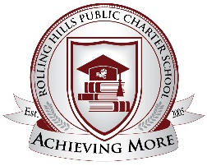
Parents’ Right to Know

This notice is to inform you of your rights as a parent of a Rolling Hills student to request and receive timely information on the professional qualifications of your children’s classroom teachers. The following information is available upon request:
- Whether the teacher has met state qualifying and licensing criteria.
- Whether the teacher is teaching under emergency or other provisional status.
- The baccalaureate degree major of the teacher & any other graduate certification or degree held.
- Whether the child is provided services by paraprofessionals and, if so, their qualifications.

All requests may be made in writing to Mr. Pratt, or you may email him at spratt@rhpcs.org.

